Hkkjrh; losZ{k.k foHkkx
SURVEY OF INDIA

 | 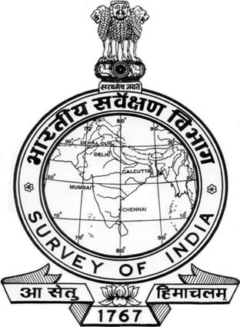 | Hkkjr ds egklosZ{kd dk dk;kZy;  Office of the Surveyor General of India  gkFkhcM+dyk ,LVsV] Mkd cDl la-37  Hathibarkala Estate, Post Box No. 37  nsgjknwu&248 001 ¼mRrjk[k.M½] Hkkjr  DEHRA DUN-248 001 (Uttarakhand), India
  VsfyQSDl | +91-135- 2744064, 2743331
  Telefax | +91-135- 2744064, 2743331
  osclkbZV | www.surveyofindia.gov.in
  Website | www.surveyofindia.gov.in
  bZ&esy | sgo.e1.soi@gov.in
  E-Mail | sgo.e1.soi@gov.in

No.E1- 365 /1198-A(coll.65) Dated the 03 February , 2015

To

The Director,
National, Geo-Spatial Data Centre,
Survey of India, Hathibarkala Estate,
DEHRA DUN.

Sub:- Implementation of the Hon'ble Supreme Court of India's Order dated
04-09-2012 in IA No.9 of 2010 in Transfer Petition (C) No.56 of 2007 – Union of India and others v/s N.K. Nair and others – circulated by Ministry of Defence.

*****

This office O.M. No.E1- 347 /1198-A(Coll.65) dated 2nd February, 2015 is sent herewith for uploading the contents under General Information – Information for Ex-Employees link in SOI Website.

Sd/-
Encl: As above.
( N.S. NEGI )
Estt. & Accounts Officer
for Surveyor General of India

Hkkjrh; losZ{k.k foHkkx
SURVEY OF INDIA

 |  | Hkkjr ds egklosZ{kd dk dk;kZy;  Office of the Surveyor General of India  gkFkhcM+dyk ,LVsV] Mkd cDl la-37  Hathibarkala Estate, Post Box No. 37  nsgjknwu&248 001 ¼mRrjk[k.M½] Hkkjr  DEHRA DUN-248 001 (Uttarakhand), India
  VsfyQSDl | +91-135- 2744064, 2743331
  Telefax | +91-135- 2744064, 2743331
  osclkbZV | www.surveyofindia.gov.in
  Website | www.surveyofindia.gov.in
  bZ&esy | sgo.e1.soi@gov.in
  E-Mail | sgo.e1.soi@gov.in

No.E1- 347 /1198-A(coll.65) Dated the 02 February , 2015

OFFICE MEMORANDUM

Sub:- Implementation of the Hon'ble Supreme Court of India's Order dated
04-09-2012 in IA No.9 of 2010 in Transfer Petition (C) No.56 of 2007 – Union of India and others v/s N.K. Nair and others – circulated by Ministry of Defence.

*****

CDA (O), Pune has sought the consent of forwarding the service particulars of 79 officers who were served in Survey of India as well as Indian Army as early as possible for further action for working out Rank Pay Arrears.

The above is brought to the notice of all the concerned 79 officers, as per the list attached to this O.M. No.E1-3567/1198-A(coll.65) dated 10-12-2014 and accordingly consent of service particulars as above may be conveyed to CDA (O), Pune directly, as desired by them with a copy to this office.


( M.C. GAUR )
Superintending Surveyor
for Surveyor General of India

